**Name:**

**CSC 229 Homework 2 50 Points**

**Submit: the completed java file included with the problem statement through BB and as an attachment to an email to** [**seyedt1@southernct.edu**](mailto:seyedt1@southernct.edu)

**(25) 1. Complete case for problem 1 in paint method to draw the following shape based on current width and height of the visible frame, leave 20 pixels space around the border.**

**(divide width and height of the bounding rectangle and draw the lines as shown)**

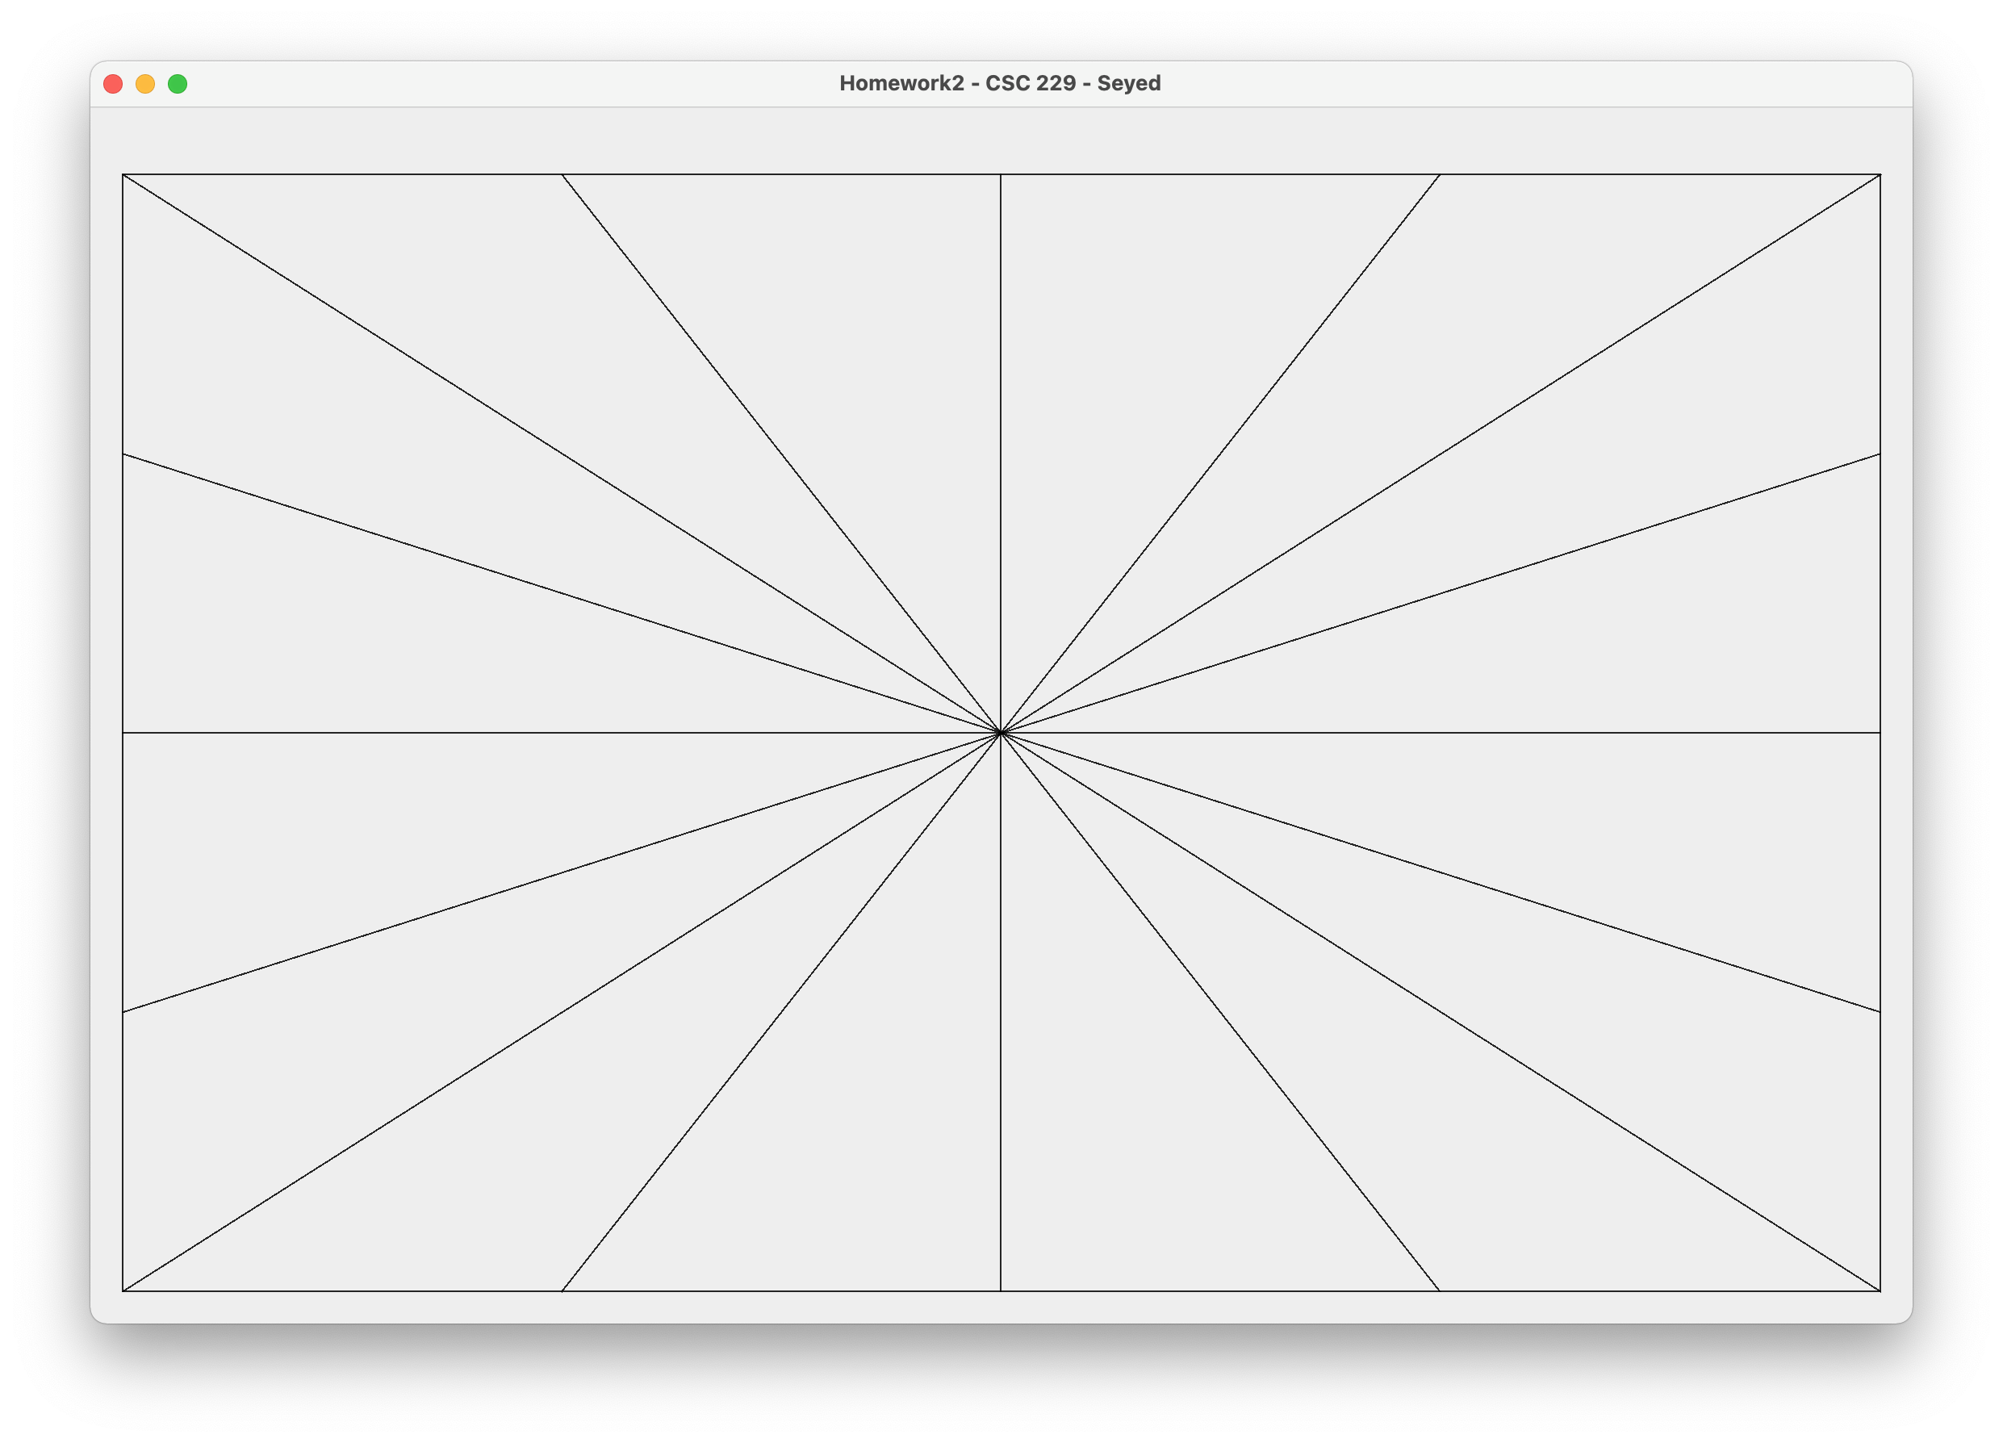

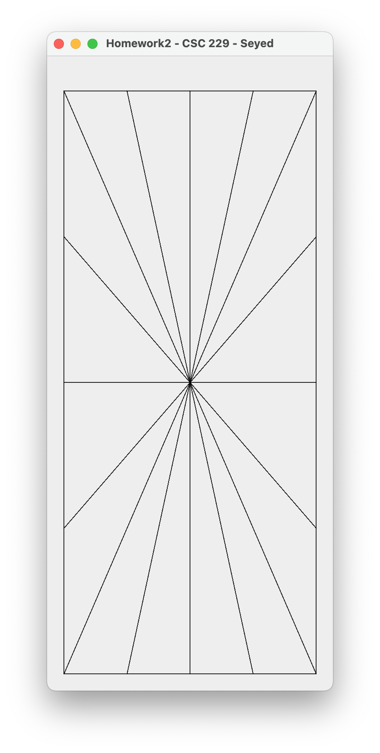

**(25) 2. Complete case for problem 2 in paint method to draw the following shape based on current width and height of the visible frame, leave 20 pixels space around the border.**

**Divide width and height of the bounding rectangle to three equal segments and draw the lines and ellipses as shown.**

**Bonus (no partial credit)**

**Complete case “Circles” in the paint method to draw concentric circles (NOT OVALS) based on the current width and height of the frame. (25 points)**

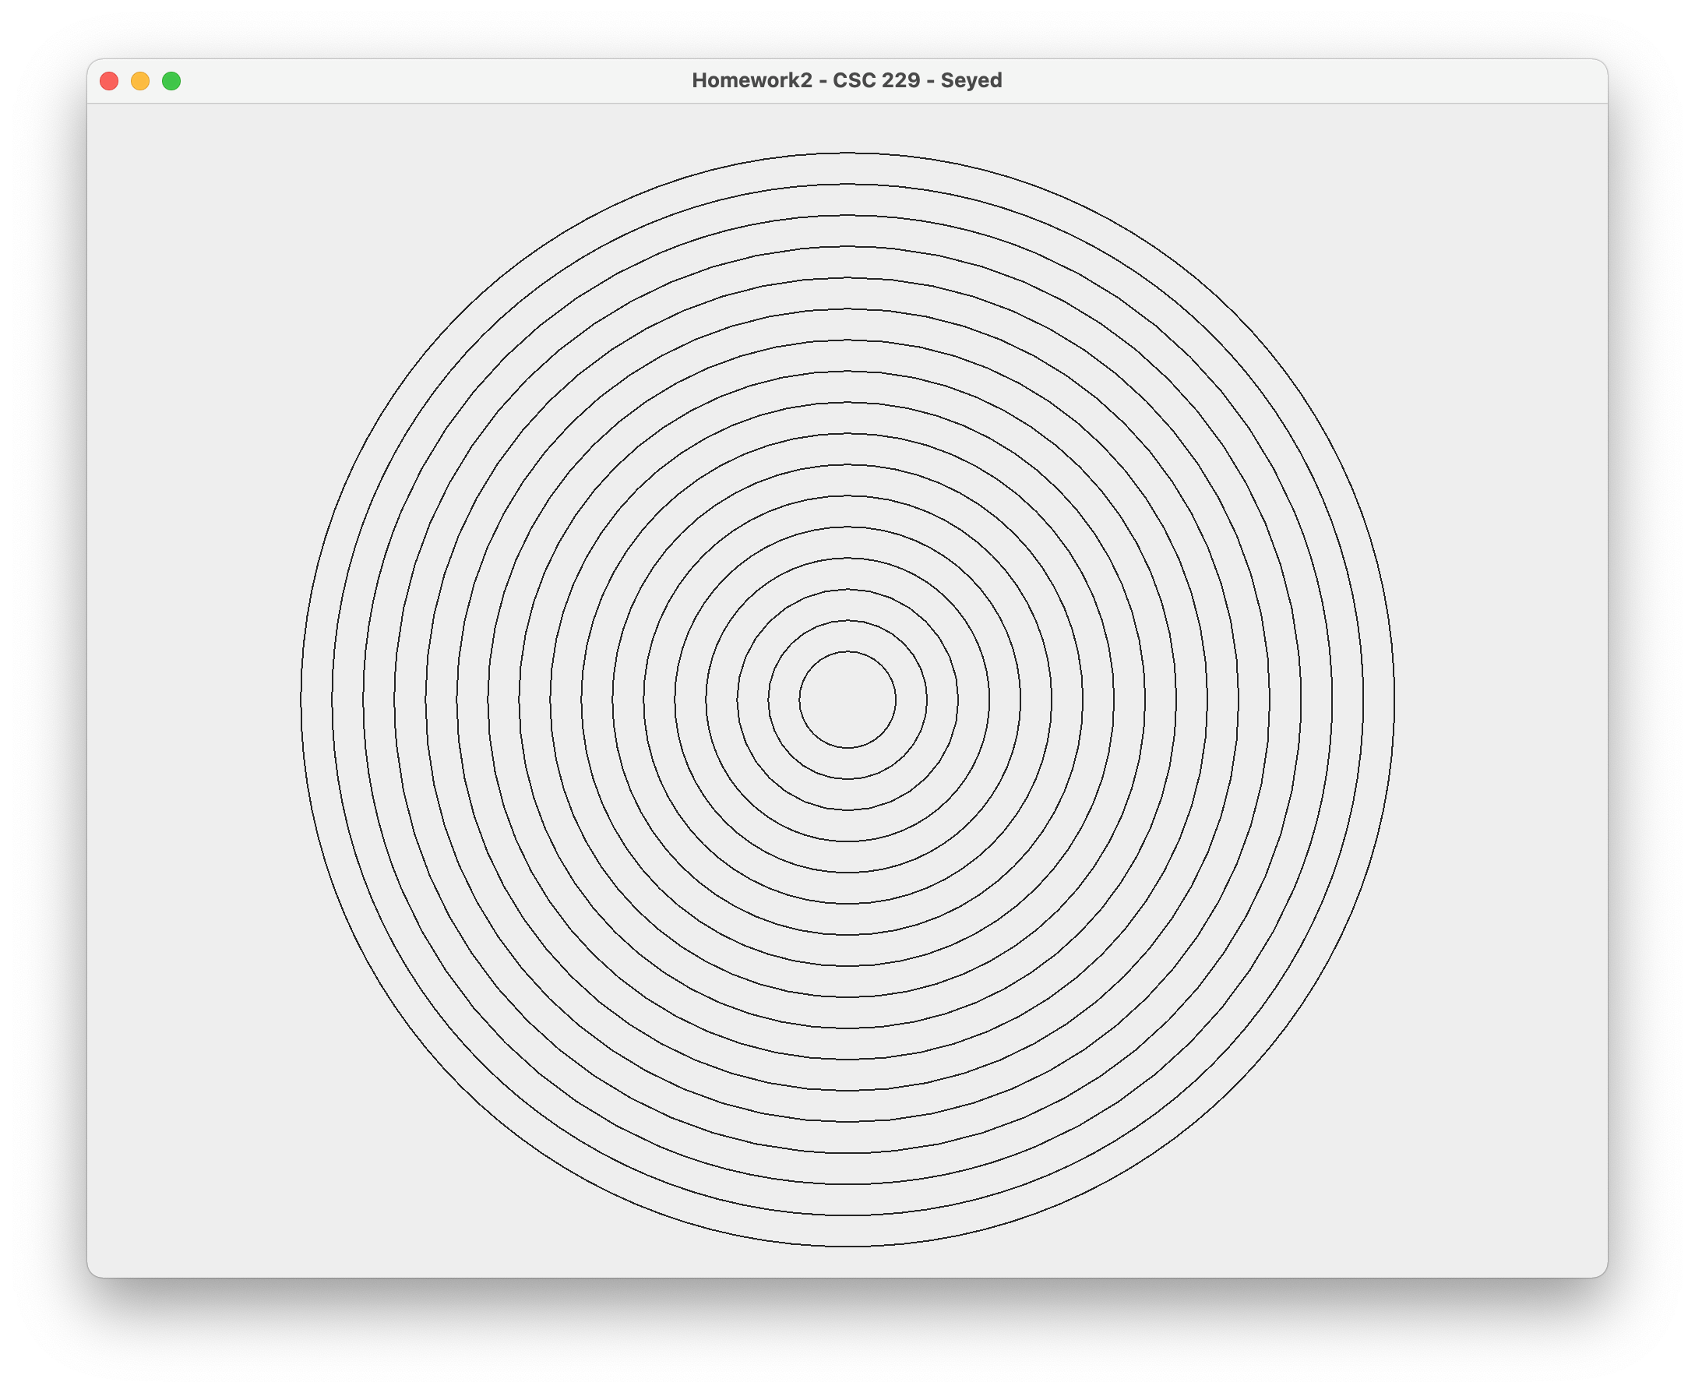

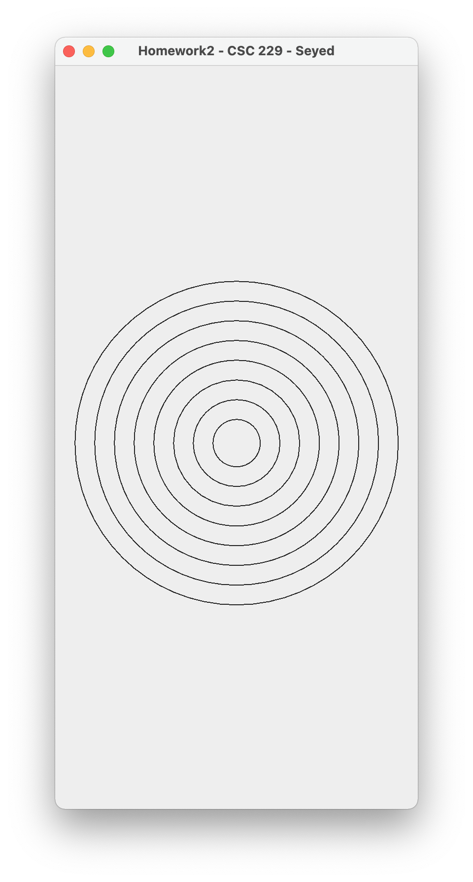

**Complete case “Triangles” in the paint method to draw largest possible concentric equilateral triangles (three sides are the same size) based on the current width and height of the frame. (50 points)**

